**Batch: H2-1 Roll No.: 16010122151**

**Experiment :-03**

|  |
| --- |
| **Title:**  Importing Data and exploring the data |

# Objective:

# 1. To learn how to import dataset from various file format

# *Text, csv, pdf, excel, word*

# 2. To learn how to import dataset from various server

# Example (MySQL, MSSQL, Oracle, DB2, Google spreadsheets, Google drive, AWS, other)

# Minimum One connection with Server (Student choice mentioned in Objective 2)

# 3. Explore the data over platform

# Live data and Extracted data

# Data types

# Combining two data sources

# View data

# Sort option

# Measures and dimensions

# Splitting the column

# Discrete and continues values

# Drill down and Hierarchies

# Grouping

# Course Outcome:

# CO1: Learn how to locate and download datasets, extract insights from that data and present their findings in a variety of different formats.

# Books/ Journals/ Websites referred:

(Students should write)

Google

Kaggle

# Resources used:

# Kaggle

# Tableau

# Theory (About Data Preprocessing):

Data preprocessing is an important step in the data mining process.

It refers to the cleaning, transforming, and integrating of data in

order to make it ready for analysis. The goal of data preprocessing

is to improve the quality of the data and to make it more suitable for

the specific data task.

# Following points should be written by students

# Different approaches of importing dataset:

# Import from various file format (PDF, Excel, .CSV, .txt)

# Import from server

# Platform used by the student:

# Tableau

# Working: (Screenshots of various file format imported in software)

# 

# DATA TYPES:

# 

**SORTED BY ROW ID**

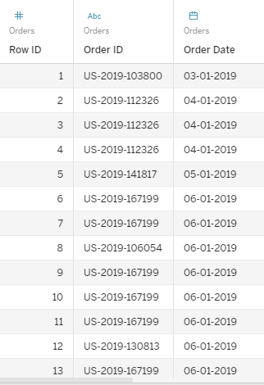

**SORTED BY SHIP DATE**

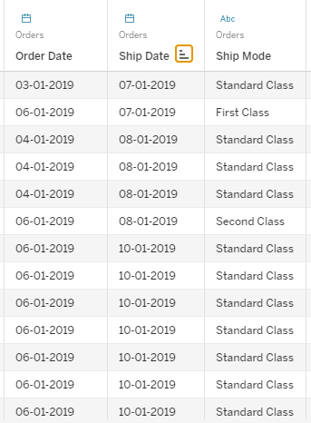

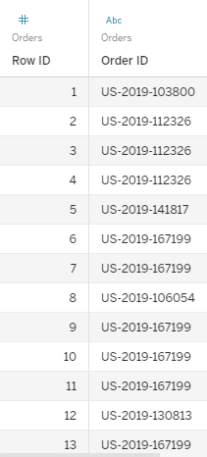

# Conclusion (Students should write in their own words):

# I have learned how to use tableau to view datasets sort them hide columns split columns and the difference between live and extracted data.

**Date: _____________ Signature of faculty in-charge**

# Post Lab Question:

# List down types of data Tableau (any other you use) can import?

# Text, date, date and time, numerical values, Boolean value, geographic value

# What is significance of Measures and Dimensions in dataset stored in Tableau(any other you use)?

Data fields are made from the columns in your data source. Each field is automatically assigned a data type (such as integer, string, date), and a role: Discrete Dimension or Continuous Measure (more common), or Continuous Dimension or Discrete Measure (less common).

* *Dimensions* contain qualitative values (such as names, dates, or geographical data). You can use dimensions to categorize, segment, and reveal the details in your data. Dimensions affect the level of detail in the view.
* *Measures* contain numeric, quantitative values that you can measure. Measures can be aggregated. When you drag a measure into the view, Tableau applies an aggregation to that measure (by default).